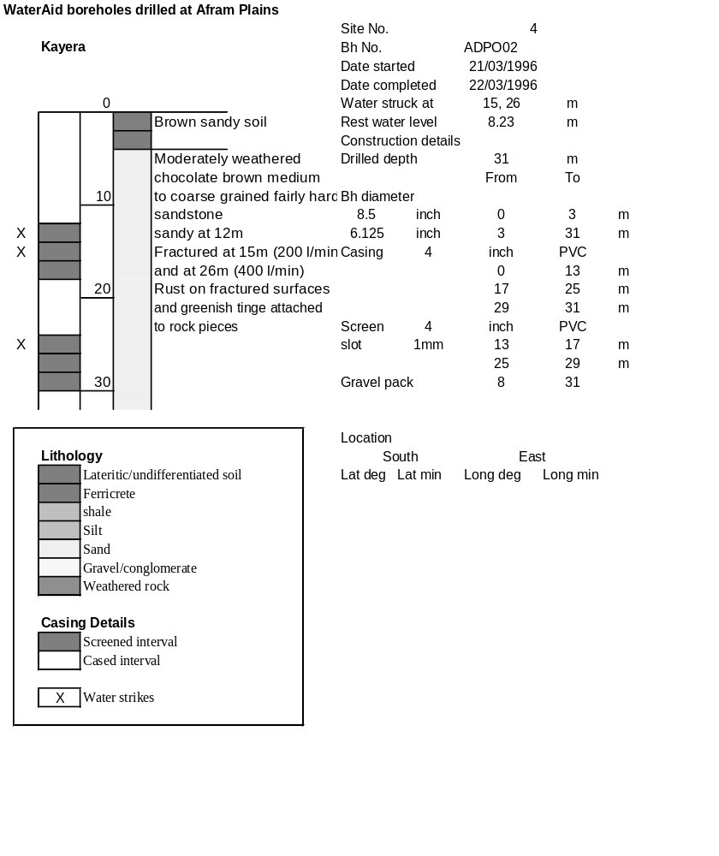

Ghana | Test pumping
Borehole No. |  | APDO2
Hole No |  | 2
Village |  | Kayera
Date |  | 15/04/1996
Point above GL |  | 0.5 | m
Pump depth |  | 23 | m
SWL |  | 8.73 | m
Start Time |  | 14:50
Drawdown test |  |  |  |  | Recovery test
time | pwl (m) | Q l/min | dd | sc | Time | wl (m) | s' | t/t'
0.00 | 8.73 | 120.00 | 0.00 |  | 0.00 | 13.41 | 4.68
1.00 | 9.46 | 120.00 | 0.73 | 164.38 | 1.00 | 13.19 | 4.46 | 181.00
2.00 | 9.63 | 120.00 | 0.90 | 133.33 | 2.00 | 13.05 | 4.32 | 91.00
3.00 | 9.77 | 120.00 | 1.04 | 115.38 | 3.00 | 12.95 | 4.22 | 61.00
4.00 | 9.90 | 120.00 | 1.17 | 102.56 | 4.00 | 12.85 | 4.12 | 46.00
5.00 | 10.02 | 120.00 | 1.29 | 93.02 | 5.00 | 12.76 | 4.03 | 37.00
6.00 | 10.12 | 120.00 | 1.39 | 86.33 | 6.00 | 12.68 | 3.95 | 31.00
7.00 | 10.22 | 120.00 | 1.49 | 80.54 | 7.00 | 12.60 | 3.87 | 26.71
8.00 | 10.30 | 120.00 | 1.57 | 76.43 | 8.00 | 12.54 | 3.81 | 23.50
9.00 | 10.39 | 120.00 | 1.66 | 72.29 | 9.00 | 12.47 | 3.74 | 21.00
10.00 | 10.47 | 120.00 | 1.74 | 68.97 | 10.00 | 12.41 | 3.68 | 19.00
11.00 | 10.56 | 120.00 | 1.83 | 65.57 | 12.00 | 12.31 | 3.58 | 16.00
12.00 | 10.63 | 120.00 | 1.90 | 63.16 | 14.00 | 12.22 | 3.49 | 13.86
13.00 | 10.69 | 120.00 | 1.96 | 61.22 | 16.00 | 12.13 | 3.40 | 12.25
14.00 | 10.75 | 120.00 | 2.02 | 59.41 | 18.00 | 12.06 | 3.33 | 11.00
15.00 | 10.82 | 120.00 | 2.09 | 57.42 | 20.00 | 11.98 | 3.25 | 10.00
16.00 | 10.87 | 120.00 | 2.14 | 56.07 | 22.00 | 11.91 | 3.18 | 9.18
17.00 | 10.93 | 120.00 | 2.20 | 54.55 | 24.00 | 11.85 | 3.12 | 8.50
18.00 | 10.98 | 120.00 | 2.25 | 53.33 | 26.00 | 11.78 | 3.05 | 7.92
19.00 | 11.04 | 120.00 | 2.31 | 51.95 | 28.00 | 11.72 | 2.99 | 7.43
20.00 | 11.10 | 120.00 | 2.37 | 50.63 | 30.00 | 11.68 | 2.95 | 7.00
22.00 | 11.19 | 120.00 | 2.46 | 48.78 | 35.00 | 11.56 | 2.83 | 6.14
24.00 | 11.29 | 120.00 | 2.56 | 46.88 | 40.00 | 11.46 | 2.73 | 5.50
26.00 | 11.36 | 120.00 | 2.63 | 45.63 | 45.00 | 11.35 | 2.62 | 5.00
28.00 | 11.43 | 120.00 | 2.70 | 44.44 | 50.00 | 11.29 | 2.56 | 4.60
30.00 | 11.50 | 120.00 | 2.77 | 43.32 | 60.00 | 11.15 | 2.42 | 4.00
35.00 | 11.67 | 120.00 | 2.94 | 40.82 | 70.00 | 11.04 | 2.31 | 3.57
40.00 | 11.82 | 120.00 | 3.09 | 38.83 | 80.00 | 10.85 | 2.12 | 3.25
45.00 | 11.94 | 120.00 | 3.21 | 37.38 | 90.00 | 10.75 | 2.02 | 3.00
50.00 | 12.05 | 120.00 | 3.32 | 36.14 | 100.00 | 10.71 | 1.98 | 2.80
55.00 | 12.15 | 120.00 | 3.42 | 35.09 | 110.00 | 10.67 | 1.94 | 2.64
60.00 | 12.26 | 120.00 | 3.53 | 33.99 | 120.00 | 10.49 | 1.76 | 2.50
70.00 | 12.47 | 120.00 | 3.74 | 32.09
80.00 | 12.60 | 120.00 | 3.87 | 31.01
90.00 | 12.72 | 120.00 | 3.99 | 30.08
100.00 | 12.84 | 120.00 | 4.11 | 29.20
110.00 | 12.94 | 120.00 | 4.21 | 28.50
120.00 | 13.02 | 120.00 | 4.29 | 27.97
130.00 | 13.12 | 120.00 | 4.39 | 27.33
140.00 | 13.25 | 120.00 | 4.52 | 26.55
160.00 | 13.34 | 120.00 | 4.61 | 26.03
180.00 | 13.41 | 120.00 | 4.68 | 25.64

